David W. Springer
August 11, 1969 – August 10, 2002

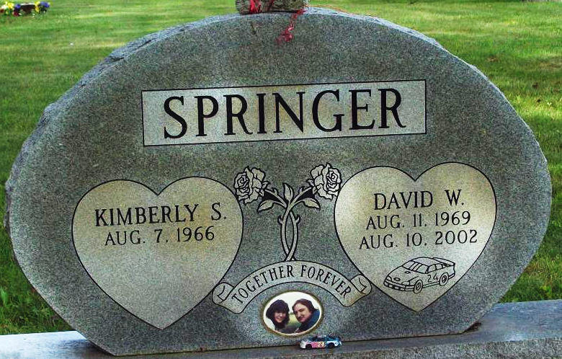
Photo by Alicia Kneuss

David W Springer
in the Indiana, U.S., Death Certificates, 1899-2017
Name David W Springer
Gender Male
Race White
Marital Status Married
Age 32
Birth Date 11 Aug 1969
Birth Place Decatur, Indiana
Death Date 10 Aug 2002; work accident
Death Place Fort Wayne, Allen, Indiana, USA
Death Registration Date 2002
Father Calvin L Springer
Mother Linda L Johnson
Spouse Kimberly Pingry
Informant Mrs. Kimberly Springer; wife; Decatur, Indiana
Burial August 14, 2002; Decatur Cemetery; Decatur, Indiana

