Cleo L. (DeBolt) Springer
November 1, 1906 – February 9, 1993

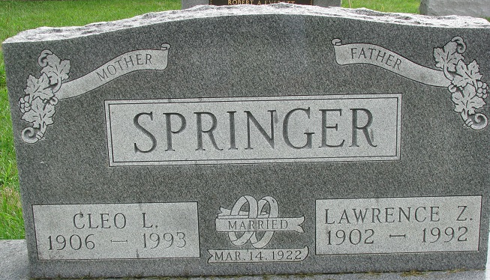
Photo by Alicia Kneuss

Cleo L. Springer, 86, of rural Decatur died yesterday in Adams County Memorial Hospital. The Van Wert County, Ohio, native was the widow of Lawrence Z., who died last year.
Surviving are daughters, Marjorie M. Conrad of Decatur and Patsy A. Hackman of Angola; sons, Gerald W. of Decatur and Donald M.; sisters, Lucille Secaur of Decatur and Lavon Kemp of Fort Wayne; brother, Kenneth DeBolt of Decatur; nine grandchildren; 25 great-grandchildren; and four great-great- grandchildren.
Services are 3 p.m. tomorrow in Zwick-Sefton & Jahn Funeral Home, Decatur, where calling is 1 to 3 p.m. tomorrow. Burial will be in Decatur Cemetery.
News-Sentinel, Allen County, Indiana
Wednesday, February 10, 1993

**
Collection: Ohio Births and Christenings, 1821-1962

Name: Cloe Lillian Debolt
Gender: Female
Birth Date: 01 Nov 1906; Birthplace: Middleberry, Van Wert, Ohio
Father's Name: Dora Debolt
Mother's Name: Vellea [sic - Della] Cook
Indexing Project (Batch) Number: C05060-3; System Origin: Ohio-EASy; Source Film Number: 1015857; Reference Number: P.115 L.26

