Arthur Paul Springer
December 3, 1979 – December 16, 2003

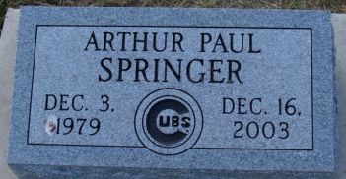
Photo by Alicia Kneuss

Arthur Paul Springer
in the Indiana, U.S., Death Certificates, 1899-2017
Name Arthur Paul Springer
Gender Male
Race White
Marital Status Single
Age 24
Birth Date 3 Dec 1979
Birth Place Decatur, Indiana
Death Date 16 Dec 2003; pneumonia
Death Place Fort Wayne, Allen, Indiana, USA
Death Registration Date 2003
Father John Springer
Mother Anna Ball
Informant John Springer; father; Decatur, Indiana
Burial December 19, 2003; Decatur Cemetery; Decatur, Indiana

