Anna B. (Ball) Springer
January 29, 1944 – December 15, 2001

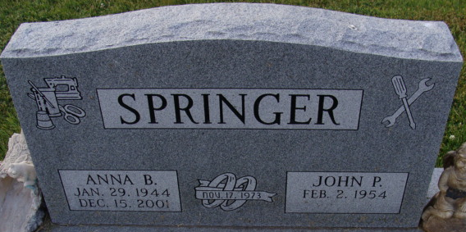
Photo by Alicia Kneuss

Anna B Springer
in the Indiana, U.S., Death Certificates, 1899-2017
Name Anna B Springer
[Anna B Ball]
Gender Female
Race White
Marital Status Married
Age 57
Birth Date 29 Jan 1944
Birth Place Westy Liberty Kentucky
Death Date 15 Dec 2001
Death Place Decatur, Adams, Indiana, USA
Death Registration Date 2001
Father Quincy Ball
Mother Mary Elizabeth Keaton
Spouse John P Springer
Informant John P. Springer; husband; Decatur, Indiana
Burial December 17, 2001; Decatur Cemetery; Decatur, Indiana

