Lucy Jane (Vail) Sprang
May 2, 1864 – October 8, 1929

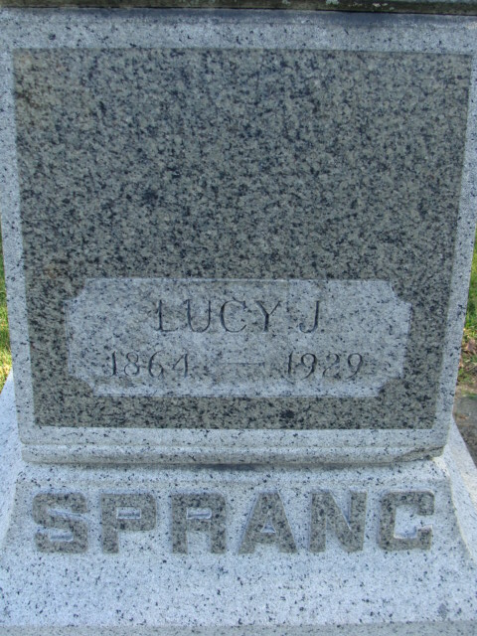
Photo by Alicia Kneuss

Lucy Jane Sprang
in the Michigan, U.S., Death Records, 1867-1952
Name Lucy Jane Sprang
Gender Female
Race White
Marital Status Married
Death Age 65
Birth Date 2 May 1864
Birth Place Ossan Ind
Death Date 8 Oct 1929
Death Place Detroit, Wayne, Michigan, USA
Parents Unknown
Spouse Daniel Sprang
Informant Mrs. Willard Rohrer
Burial October 9, 1929; Decatur, Indiana
File Number 120858

**
Indiana, U.S., Marriages, 1810-2001
Name Lucy J Vail
Gender Female
Race White
Birth Place Ossian
Marriage Date 9 Jun 1897
Marriage Place Ossian, Indiana, United States
Residence Place Ossian
Father Thomas Vail
Mother Martha A Shepard
Spouse Daniel Sprang
Page 258

