Daniel Sprang
August 22, 1854 – December 19, 1947

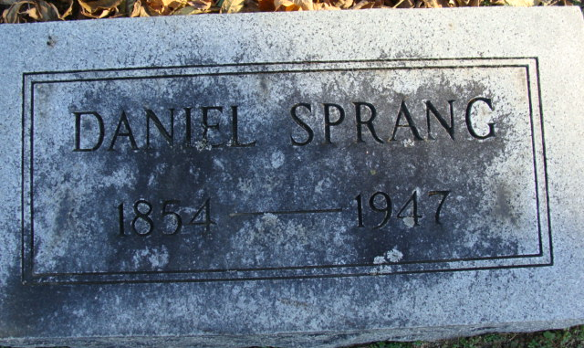
Photo by Alicia Kneuss

Collection: Ohio Deaths and Burials, 1854-1997
Name: Daniel Sprang
Gender: Male
Burial Date: 22 Feb 1947
Death Date: 19 Feb 1947; Death Place: Van Wert, Van Wert, Ohio; Age: 92 Birth Date: 22 Aug 1854; Birthplace: Ashland Co., Ohio
Occupation: Retired; Race: White; Marital Status: Widowed
Spouse's Name: Charity
Father's Name: Christian Sprang; Mother's Name: Salome Hanver

Indexing Project (Batch) Number: B01445-3; System Origin: Ohio-EASy; Source Film Number: 1952880; Reference Number: item 15 cn 331920
**

Daniel Sprang is one of the veteran business men of Decatur, has lived here nearly forty years, and has spent his life since childhood in Northeastern Indiana. His name for years was associated with merchandising at Decatur, but latterly he has been engaged in manufac-turing, being interested in the manufacturing of slack barrel stock in different parts of the country.
The Sprang name is of Swiss origin. The grandfather, Christian Sprang
was born in Alsace Lorraine. He served as a soldier under the great Napoleon in the climax of that soldier's career, from 1812 to 1815. He was once slightly wounded. He married a girl from Alsace Lorraine and settled down to farming. All their children were born in the old country, named Frederick, Jacob, Godfrey, Sarah and Christian, Jr. While most of these children were still young the family in 1822 embarked on a sailing vessel at Havre, France, and after a voyage of several weeks landed in New York City. From there they went on west to Wooster, Wayne County, Ohio, where Christian Sprang, Sr., resumed his work as a farmer. He was one of the pioneers of that section and he lived to see his family well provided with the comforts of life. His wife died in Wayne County and some years later he passed away at the home of his son Christian in Ashland County, Ohio, at the age of eighty-seven. He was a Lutheran and reared his family in the same faith, and after coming to America he became a voter of the democratic party. All his sons and daughters grew up, married in Ohio, and all except Christian spent their last years in that state.
Christian Sprang, Jr., was born in Alsace Lorraine in 1816 and was six years of age when he came to this country. In Ashland County he married Sarah Hanver. She was born in the same year and in the same province of France, and she came with her parents to America also in the same year though on a separate vessel. The Hanvers located in Ashland County, Ohio, where she grew up and remained until after her marriage.
Christian Sprang and wife after their marriage settled down on a farm near Mohicanville in Ashland County and all their children were born in that locality. The record of these two children is as follows: Fred, who died leaving a family; Magdalena, who married Frederick Hyde and died in Allen County, Indiana, leaving children; Jacob, who is a retired farmer in the State of Kansas and has a family of three daughters and one son; Philip, who died in Allen County leaving two children; Godfrey, a resident of Michigan is father of one daughter; Sarah, who lives in Defiance County, Ohio, widow of John Kuhn and mother of two sons and one daughter; Daniel, who is next to the youngest of the family; and Simon P., a farmer in Allen County, who is married and has children.
Mr. Daniel Sprang was born in Ashland County, Ohio, August 22, 1854. When he was twelve years of age the family left the scenes of his birth and moved to Allen County, Indiana, locating near Poe post office. The land which they acquired had been. only partially improved, and it remained for the energies of Christian Sprang and his sons to put it into a productive state of cultivation and a home of modest comforts. This old farm is now owned by two grandsons of Christian Sprang. Christian Sprang died in Allen County in 1875 when nearly fifty-nine years of age, and his widow died later at the home of her daughter in Defiance County, Ohio, at the age of eighty-seven. She was an active member of the Evangelical Church.
Daniel Sprang finished his education in Allen County, had a high school course, and having wisely improved his early opportunities he qualified as a teacher and followed that vocation for four years. While living in Allen County he married his first wife Alice Lichtenwalter. She was born in that county in 1857. She died at her home in Decatur May 2, 1895. She was an active member of the Methodist Episcopal Church. Mrs. Sprang's only child was Ella, who graduated from the city high school of Decatur, and was for several years a music teacher. She was twice married, her first husband being Harry Bell, and by that union there is a daughter, Margaret, now the wife of Willard Rohrer, living in Michigan. For her second husband she married C. B. Wilcox. Mrs. Wilcox died June 20, 1916.
For his present wife Mr. Sprang married Miss Lucy J. Vail. She was born in Ossian, Wells County, Indiana, May 2, 1864, and is a member of the well-known Vail family elsewhere referred to in this publication. She was well educated, and for eighteen years was one of the best-known teachers in Adams and Wells counties.
When Mr. Daniel Sprang came to Decatur in 1879 he entered the dry .goods business in partnership with Mr. Edington. In 1882 he and Charles F. True bought Mr. Edington's interest, and together they conducted a high-class store on Second Street in Decatur until 1899. Failing health compelled Mr. Sprang to retire from this business at the time and he then sold out to Mr. True. After a year of rest and recuperation he put some of his capital into business with Mr. A. T. Vail, and they took up the manufacture of barrel stock, at first at Markel, Indiana. Later they conducted plants at Warren and Bloomfield, Ohio, at Linesville, Pennsylvania, but at present they conduct their plant and find their principal supply of raw material in Arkansas and Missouri. Mr. Vail is the active manager of the business and remains on the ground, while Mr. Sprang still keeps his home at Decatur.
Mr. Sprang is one of the older members of the board of directors of the First National Bank of Decatur. He has various local interests and is one of the men most frequently called upon for cooperation with worthy public enterprises. He has served as noble grand of the Independent Order of Odd Fellows, as district deputy, has filled various chairs in the Masonic Lodge and Royal Arch Chapter, and is a member of Mizpah Temple of the Mystic Shrine at Fort Wayne. He and his wife are active in the Methodist Episcopal Church, and he has been treasurer of the church since 1889 and many years a trustee.

Standard History of Adams and Wells Counties, Indiana, Vol. II, John W. Tyndall & Orlo Ervin Lesh; Chicago: Lewis Publishing Co, 1918

