Charity E. (Harrod) Sprang
September 5, 1857 – December 1, 1943
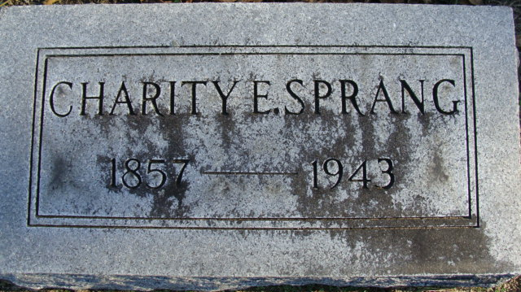
Photo by Alicia Kneuss

Sprang Funeral Here Saturday Afternoon
Prominent Resident is taken by Death

Funeral services will be held Saturday for Mrs. Charity E. Sprang, wife of Daniel Sprang, who died Wednesday afternoon at her home on North Second Street in this city. She had been ill since April and had been bedfast since suffering a stroke in June.
Services will be held at 3 pm Saturday at the Zwick Funeral Home, with Dr. M. O. Lester officiating. Burial will be in the Decatur Cemetery. The body may be viewed at the funeral home after 7 o’clock this evening.
Mrs. Sprang was born in Allen County September 5, 1857, the daughter of Morgan and Belinda Bear-Harrod. She was married to Daniel Sprang on October 26, 1930.
Mrs. Sprang was a member at the First Methodist Church, the Eastern Star and the Women’s Society of Christian Service of the church.
Surviving besides the husband, who is on the Board of Directors of the First State Bank are three brothers, Thurston Harrod of Lansing, Mich.; Clark K. Harrod of Fort Wayne and Mills Harrod of Morristown, S.D. One son, one daughter, five brothers and two sisters preceded her in death.

Adams County Historical Museum
1943B Scrapbook, image 74
Handwritten date: Thursday, December 2, 1943

**
Sprang Funeral Here Saturday Afternoon
Prominent Resident Is Taken By Death

Funeral services will be held Saturday for Mrs. Charity E. Sprang, wife of Daniel Sprang, who died Wednesday afternoon at her home on North Second street in the city. She had been ill since April and had been bedfast since suffering a stroke in June.
Services will be held at 2 p.m. Saturday at the Zwick Funeral Home with Dr. M. O. Lester officiating. Burial will be in the Decatur Cemetery. The body may be viewed at the funeral home after 7 o'clock this evening.
Mrs. Sprang was born in Allen County September 5, 1857, the daughter of Morgan and Belinda Beam-Harrod. She was married to Daniel Sprang, October 26, 1930.
Prominent in church and civic activities of the community, Mrs. Sprang was a member of the ___ Methodist church, the Eastern Star, Shakespeare club, ____ club, and the women's society of Christian service at the church.
Surviving besides the husband, who is chairman of the board of directors of the First State Bank, are three brothers, Theron Harrod of Lansing, Mich., Clark E. Harrod of Fort Wayne and Mills Harrod of Morristown S. D. One son, one daughter, five brothers and two sisters preceded her in death.
Decatur Daily Democrat, Adams County, Indiana
December 2, 1943
**
Collection: Indiana Marriages, 1780-1992
Groom's Name: Paul G. Hooper
Bride's Name: Charity E. Harrod
Marriage Date: 25 Dec 1879
Marriage Place: Fort Wayne, Allen, Indiana
Indexing Project (Batch) Number: M00708-3; System Origin: Indiana-EASy; Source Film Number: 2111520; Reference Number: pg 374

