Alice M. (Lichtenwalter) Sprang
September 14, 1857 – May 2, 1895

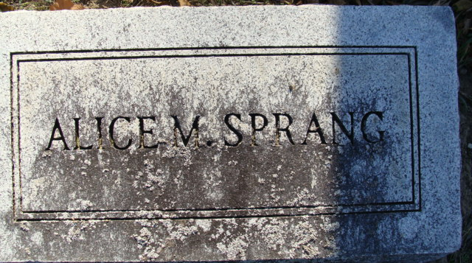
Photo by Alicia Kneuss

The sad news has reached this city of the death, at Decatur, of Mrs. Daniel Sprang, sister of Messrs. Al Owen, Wallace and William Lichtenwalter, of Fort Wayne.
The funeral will be held at Decatur today.

Fort Wayne Gazette, Allen County, Indiana
May 4 1895
**
We very briefly mentioned last week the death of Mrs. Daniel Sprang of this city, which occurred at an early hour Thursday morning. She was an estimable lady having resided in this city since 1880, and was known as an ardent, faithful worker in church circles.
She was kind and affectionate to her neighbors and friends, and respected by everyone who knew her.
Her maiden name was Alice Lichtenwalter, being born at Williamsport, September 14, 1857; aged at the time of her death, thirty-seven years, seven months and eighteen days. In May, 1875, she was married to her present bereaved husband who with their accomplished daughter Ellen, still survives her.
The family was quite a devoted one, and the sorrow that has befallen cannot be expressed in words. The funeral services took place from the Methodist church last Saturday afternoon, the services being a beautiful commemoration to a life that was useful as well as ornamental. The church edifice was crowded with her many friends who sought to pay their respects to the useful life that had fulfilled its mission on this earth, and had gone to its just reward in the world above. Rev. Gregg's discourse was a pleasing reminiscence of her Christian life. Interment in Maplewood.
Democratic Press, Decatur, Indiana
Thursday, May 9, 1895

