Verna Beatrice (Mann) Sprague
April 17, 1893 – September 23, 1978

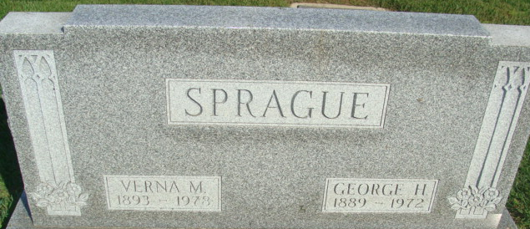
Photo by Alicia Kneuss

Verna Beatrice Sprague
in the Indiana, U.S., Death Certificates, 1899-2017
Name Verna Beatrice Sprague
[Verna Beatrice Mann]
Gender Female
Race White
Marital Status Widowed
Age 85
Birth Date 17 Apr 1893
Birth Place Indiana
Death Date 23 Sep 1978
Death Place Decatur, Adams, Indiana, USA
Death Registration Date 1978
Father Joseph Mann
Mother Louisa Kiess
Informant Mrs. Phyllis Grandstaff; Decatur, Indiana
Burial September 25, 1978; Decatur Cemetery; Decatur, Indiana

