Timothy Sprague
March 5, 1885 – February 18, 1971

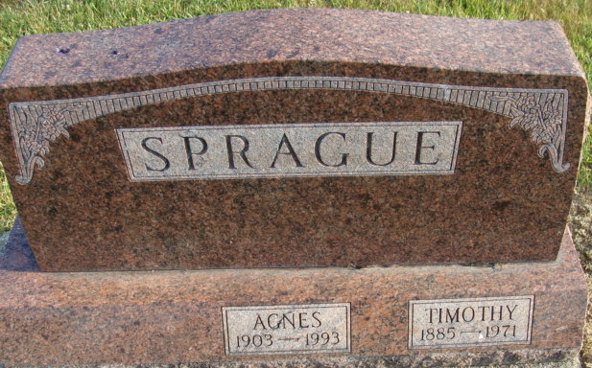
Photo by Alicia Kneuss

Timothy Sprague Taken By Death
Timothy Sprague, 85, of 1125 West Jackson Street, died at 11 p.m. Thursday at the Adams County Memorial Hospital, following an extended illness. He was a retired employee of the General Electric Co. and Niblick & Co. Store.
Born in Allen County March 5, 1885, he was a son of John T. and Sarah E. Roudebush-Sprague, and was married to Agnes Huston Jan. 25, 1932. Mr. Sprague was a member of the First United Methodist Church and the Moose Lodge.
Surviving are his wife; two sons, Earl T. and Robert W. Sprague, both of Fort Wayne; two sisters, Mrs. Ida Cross of Kalamazoo, Mich., and Mrs. Hazen (Marie) Moore of Decatur; two brothers, Oscar Sprague of Decatur and Marion Sprague of Fort Wayne; and one grandchild.
Funeral services will be conducted at 2 p.m. Sunday at the Winteregg-Linn Funeral Home with Rev. Sylvester Martin officiating. Burial will be in the Decatur Cemetery. Friends may call at the funeral home after 2 p.m. Saturday until time of the services. Moose memorial services will be held at 7 p.m. Saturday.
Decatur Daily Democrat, Adams County, Indiana
Friday, February 19, 1971

