Sarah Elizabeth (Roudebush) Sprague
August 21, 1863 – May 11, 1930

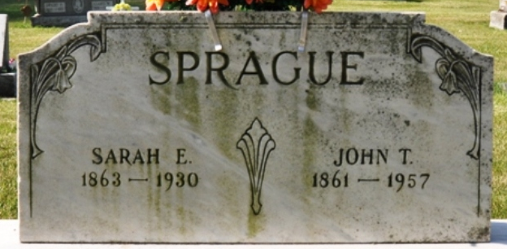
Photo by Deb Curry

Sarah Eizefath Sprague
in the Indiana, U.S., Death Certificates, 1899-2017
Name Sarah Eizebath Sprague
[Sarah Elizabeth Roudebush]
Gender Female
Race White
Marital Status Married
Age 66
Birth Date 21 Aug 1863
Birth Place Indiana
Death Date 11 May 1930
Death Place Decatur, Adams, Indiana, USA
Death Registration Date 1930
Father James Roudebush
Mother Susana King
Spouse John Sprague
Informant John T. Sprague; Decatur, Indiana
Burial May 13, 1930; Decatur Cemetery

