Sarah Ann (McTigue) Sprague
January 22, 1881 – December 11, 1937

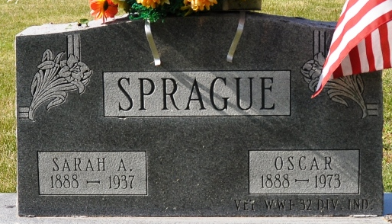
Photo by Deb Curry

DEATH TAKES DECATUR WOMAN
Mrs. Sarah Sprague, 56, Wife of Oscar Sprague, Dies Saturday

DECATUR, Dec. 13 – Mrs. Sarah Ann Sprague, 56, wife of Oscar Sprague, of this city, died Saturday morning at 3:30 o'clock at the residence, 320 N. 12th St. Death was caused by complications following an illness of several months.
The deceased was born in Arcola on January 22, 1881 (sic), the daughter of Mr. and Mrs. Tom McTigue. She was a member of the firemen's auxiliary organization of this city.
Surviving besides the husband are the following brothers and sisters: Mrs. C. C. Schuck of Garrett, Tom McTigue of Fort Wayne, Mrs. J. W. Kaminski of Bakersfield, California; Mrs. Mari? Goland of Chicago and Edward Hoben of Fort Wayne.

Unknown newspaper clipping
Handwritten date: Monday, December 13, 1937
**

Indiana, Death Certificates, 1899-2011

Name: Sarah Ann Sprague
Gender: Female
Race: White
Age: 56
Marital Status: Married
Birth Date: 22 Jan 1881
Birth Place: Indiana
Death Date: 11 Dec 1937; age 56 years, 10 months, 19 days
Death Place: Decatur, Adams, Indiana, USA
Father: Tom McTigue
Mother: Sarah Jahals??
Spouse: Oscar Sprague
Burial: Dec. 13, 1937 Decatur Cem

