Richard M. Sprague
August 30, 1879 – September 13, 1879

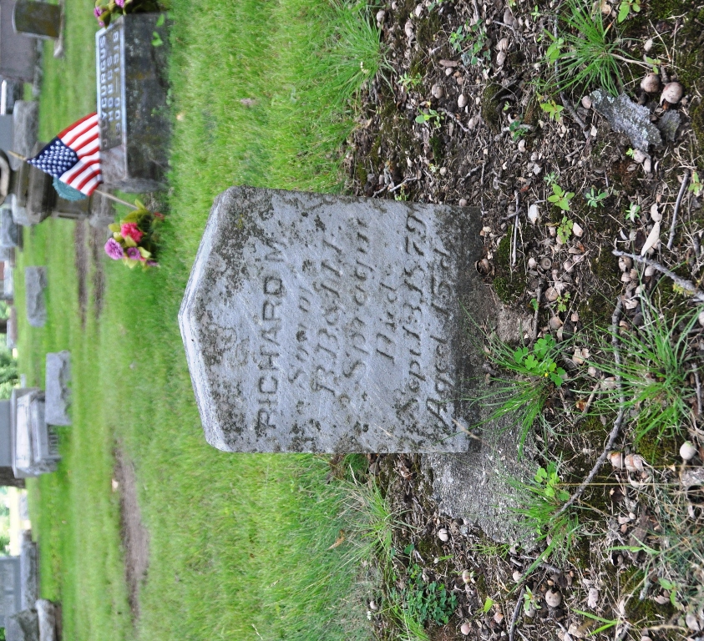
Photo by Deb Curry

Richard M Sprague from tree Main Family Tree
Birth 30 Aug 1879
Death 13 Sep 1879
Father Randall Buchanan Sprague (1824-1924)
Mother Mary Frances Fisher (1840-1879)
2887 People 1 Record 19 Sources

