Rebecca (Steele) Sprague
April 3, 1857 – July 22, 1952

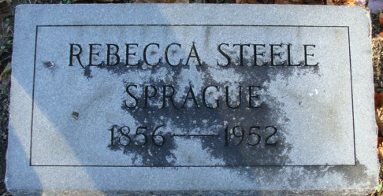
Photo by Alicia Kneuss

Rebecca Sprague
in the Indiana, U.S., Death Certificates, 1899-2017
Name Rebecca Sprague
Gender Female
Race White
Marital Status Widowed
Age 95
Birth Date 3 Apr 1857
Birth Place Indiana
Death Date 22 Jul 1952
Death Place Fort Wayne, Allen, Indiana, USA
Death Registration Date 1952
Parents Unknown
Informant Ralph Sprague; Monroeville, Indiana
Burial July 24, 1952; Decatur Cemetery; Decatur, Indiana

**
Indiana, U.S., Marriages, 1810-2001
Name Rebecca Steele
Gender Female
Race White
Age 48
Event Type Marriage Registration (Marriage)
Birth Date 2 Apr 1861
Birth Place Kirkland Twp, Adams, Indiana
Marriage Date 26 Jan 1910
Marriage Place Indiana, United States
Residence Place Decatur, Indiana
Father Joseph Steele
Mother Sarah Serring
Spouse Elmer E Sprague
Page 126

