Oscar Sprague
June 23, 1888 – June 22, 1973

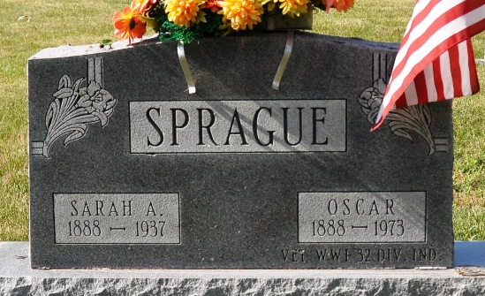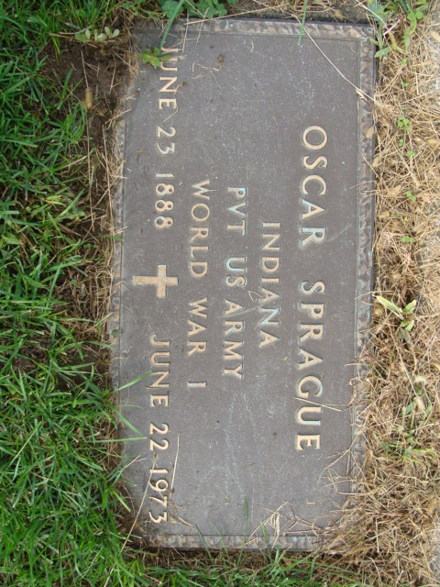
Photo by Deb Curry & Alicia Kneuss

Oscar Sprague Dies at Hospital
Oscar Sprague, 84, of 322 N. 12th Street, a retired Niblick Co. employee, died at 7:45 a.m. today at the Adams County Memorial Hospital. He had been hospitalized three days. Mr. Sprague was a World War I veteran and volunteer fireman for 50 years.
Born in Allen County on June 23, 1888, he was the son of John T. and Sarah E. Roudebush-Sprague, and was married to Sadie McTigue in 1935. She preceded him in death in 1937.
Surviving are two sisters, Mrs. Hazen (Marie) Moore of Decatur, and Mrs. Ida Cross of Kalamazoo, Mich.; and one brother, Marion Sprague of Fort Wayne. One brother, Tim, preceded him in death.
Funeral services will be held at 10:30 a.m. Monday at the Winteregg-Linn Funeral Home with Rev. Sylvester Martin officiating. Burial will be in the Decatur Cemetery. Friends may call at the funeral home after 7 p.m. Saturday.

Decatur Daily Democrat, Adams County, Indiana
Friday, June 22, 1973

