Mary Ann (Whitehurst) Sprague
March 18, 1849 – May 5, 1919

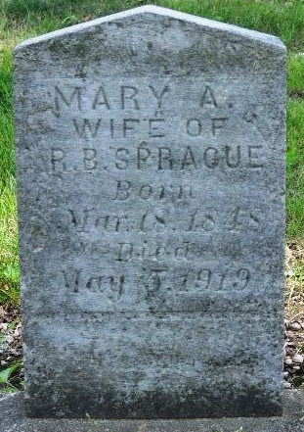
Photo by Deb Curry

WHILE ON VISIT - Death Called Mrs. Randall Sprague - Died Monday at Homestead - In Allen County - Funeral Will be Here at M. E. Church Wednesday at Ten O'clock
The funeral of Mrs. Randall Sprague, of Marshall Street, will be held Wednesday morning at 10:30 o'clock from the Decatur Methodist church. Her death occurred yesterday morning on the old Sprague homestead, near Monroeville, or across the county line, in Allen County, where she and Mr. Sprague had gone six weeks ago to visit with his son, Charles Sprague and family. She had been in poor health for four years or more, suffering from heart trouble and complications. Her health had been particularly bad since an operation two years ago.
She was seventy-one years of age. Prior to her marriage to Mr. Sprague sixteen years ago, she was Mrs. Mary Hudson. From the former marriage, there are nine children: James Hudson and Mrs. Burt David, of Sturgis, Mich.; Will Hudson, of Hammond; John, of New York; Iona, in California; Mrs. Susan May Foster, Fort Wayne; Charles Jacob, of Lima, O.; Ollie, of Fort Wayne.
The deceased was a member of the Methodist Church and of the W. R. C.

Decatur Daily Democrat, Adams County, Indiana
Tuesday evening, May 6, 1919
**
Mary Ann Spragne
in the Indiana, U.S., Death Certificates, 1899-2017
Name Mary Ann Sprague
[Mary Ann Whitehurst]
Gender Female
Race White
Marital Status Married
Age 70
Birth Date 18 Mar 1849
Birth Place Adams County, Indiana
Death Date 5 May 1919
Death Place Madison, Allen, Indiana, USA
Death Registration Date 1919
Father Jacob Whitehurst
Mother Rachel Ball
Spouse Randall Sprague
Informant Randall Sprague; Decatur, Indiana
Burial May 7, 1919; Decatur Cemetery

