Mary Ann (Johnson) Sprague
1841 – October 24, 1901

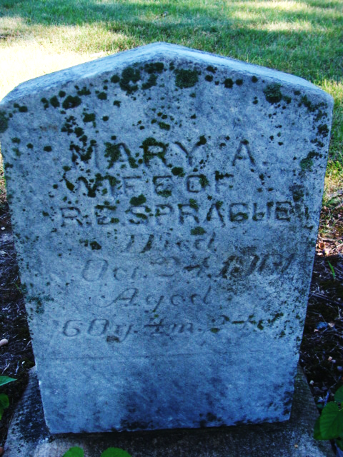
Photo by Alicia Kneuss

Mrs. Mary Sprague, an old resident of Union Township, died Thursday morning of peritonitis, after an illness of several days. She was sixty years old and one of the best-known ladies of her community.
The funeral services were held Saturday morning at the Alpha church.
Decatur Democrat; Adams County, Indiana
Thursday, October 31, 1901

**
Indiana, U.S., Death Certificates, 1899-2017
Name Mary Ann Sprague
[Mary Ann Robinson]
Gender Female
Race White
Marital Status Married
Age 60
Birth Date abt 1841
Birth Place Ohio
Death Date 24 Oct 1901
Death Place Hoagland, Allen, Indiana, USA
Death Registration Date 1901
Father William Johnson
Mother Elizabeth Humbaugh?
Informant Harry Sprague; Decatur, Indiana
Burial October 26, 1901; Alpha Cemetery

