Margaret E. (Moats) Sprague
October 26, 1923 – March 17, 2005

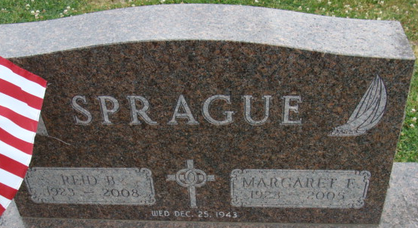
Photo by Alicia Kneuss

Margaret E. Sprague, 81, of Decatur, died Thursday, March 17, 2005, 9:30 a.m., in Decatur. She had taught English in the Wabash County and Decatur school systems for over 30 years.
Survived by husband, Reid Sprague Jr. of Decatur; son, Reid B. Sprague III of Severna Park, Md.; and daughters, Ann E. (Ted) Wenning of Decatur and Maggie (Earl) Sprague-Robinson of Seattle, Wash. She was preceded in death by a son, Paul H.
Service is 1 p.m. Monday at Zwick & Jahn Funeral Home, Decatur. Calling is from 2 to 3 p.m. Saturday in the Woodcrest Chapel, and from noon to 5 p.m. Sunday at the funeral home.

Fort Wayne Newspapers, Allen County, Indiana
March 19, 2005
**
Indiana, U.S., Death Certificates, 1899-2017
Name Margaret E Sprague
Gender Male
Race White
Marital Status Married
Age 81
Birth Date 26 Oct 1923
Birth Place Benton Harbor, Michigan
Death Date 17 Mar 2005
Death Place Decatur, Adams, Indiana, USA
Death Registration Date 2005
Father Harry T Moats
Mother Elizabeth A Brown
Spouse Reid B Sprague
Informant Ann E. Wenning; daughter; Decatur, Indiana
Burial March 21, 2005; Decatur Cemetery; Decatur, Indiana

