John Taylor Sprague
January 30, 1861 – October 15, 1957

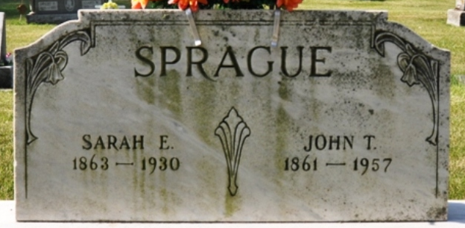
Photo by Deb Curry

Handwritten date: October 15, 1957
JOHN SPRAGUE DIES EARLY THIS MORNING
96-Year-Old Decatur Resident Dies Today

John T. Sprague, 96, one of Decatur's oldest residents, died at 5 o'clock this morning at his home, 303 North 11th Street, following a week's illness of complications. He had been in reasonably good health until the past week.
He was born in Wells County, January 30, 1861, a son of Randall and Mary Fisher-Sprague. He and his family lived on various farms in Wells and Allen Counties until 1891, when Mr. Sprague moved to Decatur, and farmed at the same location where he died. At that time, the area was outside the Decatur city limits.
Mr. Sprague hauled logs to sawmills in this area for a number of years, later entered the ditching business and also was an employee of the city of Decatur.
He was married to Sarah Elizabeth Raudebush Feb. 14, 1883. Mrs. Sprague preceded him in death in 1930.
Mr. Sprague was a member of the Trinity Evangelical United Brethren Church.
Surviving are three sons, Oscar and Timothy Sprague, both of Decatur, and Marion Sprague of Fort Wayne; two daughters, Mrs. Isabelle Cross of Kalamazoo, Mich., and Mrs. Frieda Moore of Decatur; 13 grandchildren; 17 great-grandchildren; 3 great-great-grandchildren; and one brother, Charles Sprague of Monroeville. Six brothers and one sister preceded him in death.
Funeral services will be conducted at 2 p.m. Thursday at the Black Funeral Home, the Rev. J. O. Penrod officiating. Burial will be in the Decatur Cemetery. Friends may call at the funeral home after 2 p.m. Wednesday until time of the services.

Unknown newspaper clipping
**

John Taylor Sprague from tree Burks Clayton Family
Birth 30 Jan 1861 Indiana, USA
Marriage 14 Feb 1884 Miami, Indiana, USA
Residence 1940 Decatur, Adams, Indiana, USA
Death 15 Oct 1957 Adams, Indiana, USA
Father Randall Buchanan Sprague (1828-1924)
Mother Mary Frances Fisher (1840-1879)
Spouse Sarah Elizabeth Roudabush (1863-1930)

