James A. Sprague
July 17, 1892 – March 17, 1936

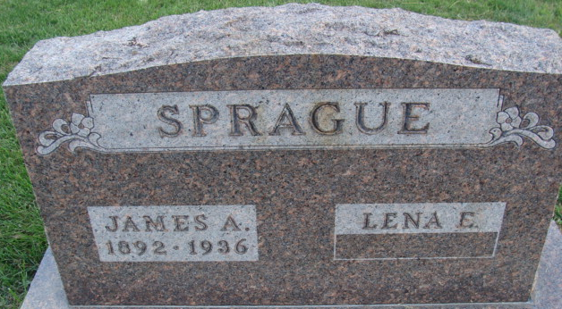
Photo by Alicia Kneuss

James Speagne
in the Indiana, U.S., Death Certificates, 1899-2017
Name James Sprague
Gender Male
Race White
Marital Status Married
Age 43
Birth Date 17 Jul 1892
Birth Place Indiana
Death Date 17 Mar 1936
Death Place Decatur, Adams, Indiana, USA
Death Registration Date 1936
Father Harry Sprague
Mother Della Moser
Spouse Lena
Informant Mrs. James Sprague
Burial March 20, 1936; Decatur Cemetery

