Helena E. “Lena” (Nidlinger) Sprague
December 25, 1890 -

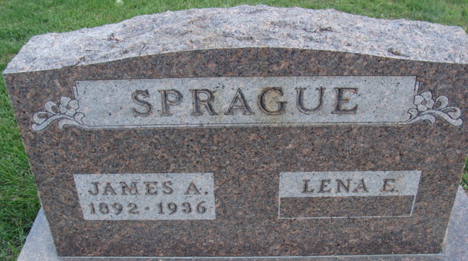
Photo by Alicia Kneuss

Helena Midlinger Sprague
in the U.S., Social Security Applications and Claims Index, 1936-2007
Name Helena Midlinger Sprague
[Helena Midlinger Midlinger]
Gender Female
Race White
Birth Date 25 Dec 1890
Birth Place Adams Co Dec, Indiana
Father Elijah N Midlinger
Mother Anna Cline
SSN xxx
Notes Apr 1939: Name listed as HELENA MIDLINGER SPRAGUE
**

Indiana, U.S., Marriages, 1810-2001
Name Lena Nidlinger
Gender Female
Race White
Age 19
Event Type Marriage Registration (Marriage)
Birth Date 25 Dec 1890
Birth Place Decatur, Indiana
Marriage Date 14 Dec 1910
Marriage Place Indiana, United States
Residence Place Decatur, Indiana
Father Elijah Nidlinger
Mother Emma Cline
Spouse James Sprague
Page 289
FHL Film Number 002321467

