Harvey V. Sprague
June 26, 1868 – December 14, 1942

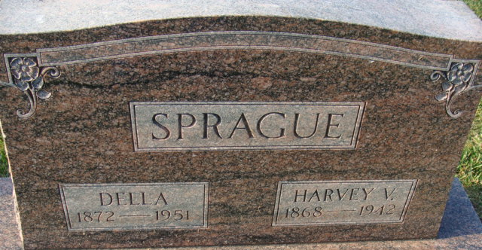
Photo by Alicia Kneuss

Harve V Sprogue
in the Indiana, U.S., Death Certificates, 1899-2017
Name Harve V Sprague
Gender Male
Race White
Marital Status Married
Age 74
Birth Date 26 Jun 1868
Birth Place Allen County, Indiana
Death Date 14 Dec 1942
Death Place Decatur, Adams, Indiana, USA
Death Registration Date 1942
Father Randal Sprague
Mother Mary Fisher
Spouse Della Moser; Decatur, Indiana
Burial December 17, 1942; Decatur Cemetery; Decatur, Indiana

