George H. Sprague
April 15, 1889 – December 20, 1972

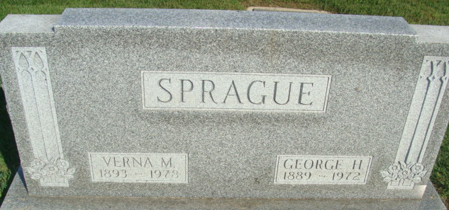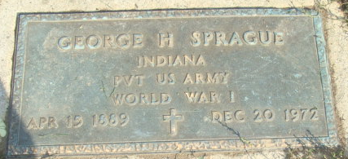
Photo by Alicia Kneuss

BULLETIN
George H. Sprague, 83, retired Decatur businessman, died suddenly at 9:20 a.m. today at his home, 209 South Fifth Street. The body was removed to the Winteregg-Linn Funeral Home.

Decatur Daily Democrat, Adams County, Indiana
Wednesday, December 20, 1972
**
George H. Sprague is Taken by Death
George H. Sprague, 83, retired Decatur businessman, died suddenly at 9:20 a.m. Wednesday at his home, 209 South Fifth Street. He had not been ill and death was unexpected. Mr. Sprague owned and operated a furniture business on South Second Street in this city for many years, retiring in 1949.
He was born in Monroe Township April 15, 1889, a son of Joshua and Emma Wolfe-Sprague, and was married to Verna M. Mann March 3, 1921. Mr. Sprague was a member of St. Mark’s United Methodist Church, the American Legion, and the Moose Lodge.
Surviving are his wife; two sisters, Mrs. Naomi Yager of Craigville route 1, and Mrs. Joseph (June) Tybor of Fort Wayne; and a brother, Chalmer Gilbert of Fort Wayne. One brother preceded him in death.
Funeral services will be conducted at 2:30 p.m. Saturday at the Winteregg-Linn Funeral Home with Rev. Fuhrman Miller officiating. Burial will be in the Decatur Cemetery. Friends may call at the funeral home from 7 to 9 p.m. Friday.
Decatur Daily Democrat, Adams County, Indiana
Thursday, December 21, 1972

