Della (Potts) Sprague
January 20, 1872 – October 20, 1951

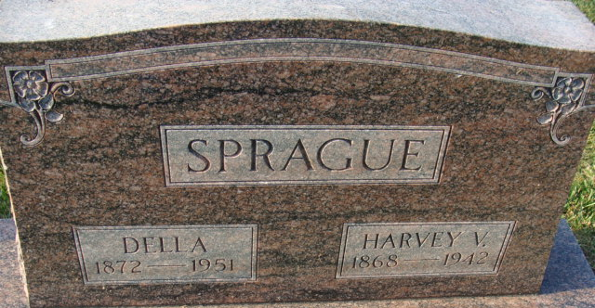
Photo by Alicia Kneuss

Della Potts Sprague
in the Indiana, U.S., Death Certificates, 1899-2017
Name Della Potts Sprague
[Della Potts Potts]
Gender Female
Race White
Marital Status Widowed
Age 79
Birth Date 20 Jan 1872
Birth Place Adams County, Indiana
Death Date 20 Oct 1951
Death Place Decatur, Adams, Indiana, USA
Death Registration Date 1951
Father Thomas Potts
Mother Elizabeth Dutcher
Informant Ralph Sprague; Monroeville, Indiana
Burial October 23, 1951; Decatur Cemetery; Decatur, Indiana

