Agnes O. (Huston) Sprague
June 3, 1903 – August 20, 1993

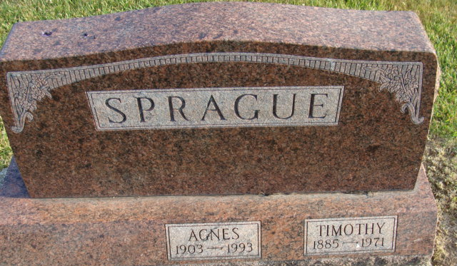
Photo by Alicia Kneuss

Agnes O. Sprague, 90, formerly of Decatur died yesterday at Indian Village Health Care Center, Fort Wayne. A Mercer County, Ohio, native, she was the widow of Timothy.
Surviving are her sons, Robert W. and Earl T., both of Fort Wayne; sisters, Ruth Fisher of Decatur; and two grandchildren.
Calling will be 2 to 5 and 7 to 9 p.m. tomorrow at Zwick, Sefton & Jahn Funeral Home, Decatur, with services at 1:30 p.m. Monday. Burial will be in Decatur Cemetery.
Preferred memorials are gifts to First United Methodist Church.

News-Sentinel, Allen County, Indiana
Saturday, August 21, 1993

**
Indiana, U.S., Death Certificates, 1899-2017
Name Agnes O Sprague
[Agnes O Huston]
Gender Female
Race White
Marital Status Widowed
Age 90
Birth Date 3 Jun 1903
Birth Place Mercer County, Ohio
Death Date 20 Aug 1993
Death Place Fort Wayne, Allen, Indiana, USA
Death Registration Date 1993
Father Henry Huston
Mother Anna E Schrall
Informant Robert W. Sprague; son; Fort Wayne, Indiana
Burial August 23, 1993; Decatur Cemetery; Decatur, Indiana

