Tiffany Nicole Spillers-Shaw
February 20, 1998 – February 20, 1998

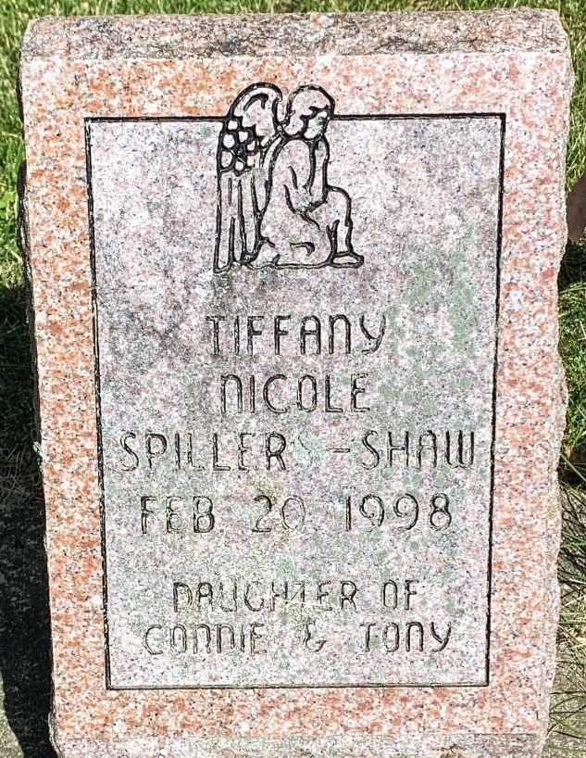
Photo by Alicia Kneuss

No further information found at this time

