Steven Alan Spiegel
March 10, 1948 – January 22, 1999

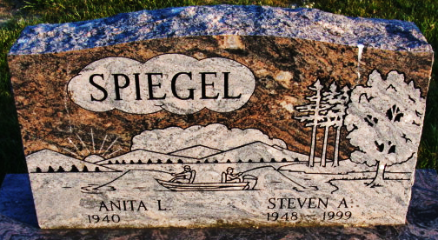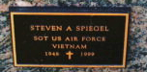
Photos by Alicia Kneuss

Steven Alan Spiegel
in the U.S., Social Security Applications and Claims Index, 1936-2007
Name Steven Alan Spiegel
[Steven A Spiegal]
Gender Male
Race White
Birth Date 10 Mar 1948
Birth Place Decatur Adam, Indiana
Death Date 22 Jan 1999
SSN xxx
Notes Dec 1963: Name listed as STEVEN ALAN SPIEGEL; 27 Jan 1999: Name listed as STEVEN A SPIEGAL

**
Steven Allen Spiegel from tree Grandel Family Tree
Birth 10 Mar 1948 Decatur, Adams, Indiana, USA
Residence 1963 Indiana, USA
Marriage 2 Mar 1973 Decatur, Adams, Indiana, USA
Death 22 Jan 1999
Father Lloyd Raymond Spiegel (1920-1977)
Mother Doris Belle Jones Spiegel Koomler (1925-2011)
Spouse Anita L. (Morrison) Spiegel (1940-2008)

