Lloyd R. Spiegel
February 16, 1920 – February 12, 1977

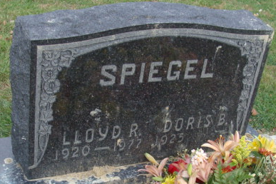
Photo by Alicia Kneuss

Lloyd R. Spiegel
in the Indiana, U.S., Death Certificates, 1899-2017
Name Lloyd R. Spiegel
Gender Male
Race White
Marital Status Married
Veteran World War II
Age 56
Birth Date 16 Feb 1920
Birth Place Minnesota
Death Date 12 Feb 1977
Death Place Decatur, Adams, Indiana, USA
Death Registration Date 1977
Father Otto Spiegel
Mother Stella Christianson
Spouse Doris Jones
Informant Mrs. Lloyd R. Spiegel; wife; Decatur, Indiana
Burial February 15, 1977; Decatur Cemetery; Decatur, Indiana

