Doris B. (Jones) Spiegel-Koomler
April 6, 1925 – October 17, 2011

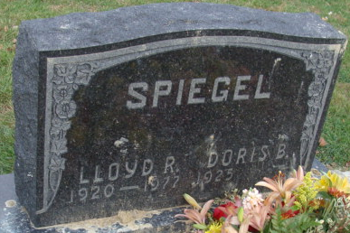
Photo by Alicia Kneuss

Doris B. (Spiegel) Koomler, 86 of Decatur, Indiana passed away Monday, October 17, 2011 at Adams Memorial Hospital. Doris was born on April 6, 1925 in Adams County, Indiana to the late William M. and Myrtle M. (Manley) Jones. On February 24, 1946 she married Lloyd R. Spiegel, he preceded her in death on February 22, 1977; and on May 2, 1981 she married Gerald Koomler, he also preceded her in death on November 10, 2008.
Doris was a member of Zion Lutheran Church. She was a homemaker and also worked for Citizen’s, United, and Sprint Telephone Company in Decatur and retired after 29 years. She was involved in the American Legion Ladies Auxiliary post #43.
Survivors include a son Stewart E. (Dian) Spiegel; two daughters Mrs. Anthony (Beverly) Wagner and Mrs. Kevin (Dianne) O’Shaughnessey and a daughter-in-law Anita Spiegel all of Decatur; 8 grandchildren and 15 great grandchildren. Preceded her in death was a son Steven Spiegel and two brothers Miles and Curtis Jones.
Funeral service will be at 1:00 p.m. Thursday, October 20, 2011 at Haggard-Sefton and Hirschy Funeral Home, with visitation on Wednesday, October 19, 2011 from 2-8 p.m. also at the funeral home. Officiating will be Pastor Phil Phifer and burial will be in Decatur Cemetery.
Memorials are to Zion Lutheran Church.

Haggard-Sefton & Hirschy Funeral Home, Adams County, Indiana
October 17, 2011

