Anita Louise (Morrison) Spiegel
February 20, 1940 -

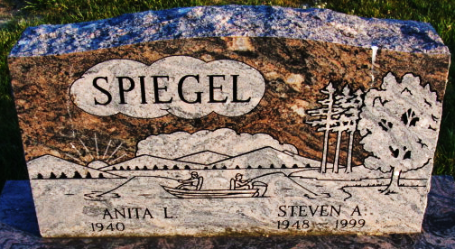
Photo by Alicia Kneuss

Anita Louise Morrison
in the Indiana, U.S., Birth Certificates, 1907-1944
Name Anita Louise Morrison
Gender Female
Birth Date 20 Feb 1940
Birth Place Decatur, Adams, Indiana, USA
Father Lawrence Morrison; age 24
Mother Dorothy Louise Howe; age 25; 1st child
Certificate Number 5020
Roll number 40474_357724
Volume Range 11 - 15

**
Steven Allen Spiegel
in the Indiana, U.S., Marriage Certificates, 1960-2012
Name Steven Allen Spiegel
Gender Male
Marriage Age 24
Birth Date abt 1949
Birth Place Indiana
Marriage Date 2 Mar 1973
Marriage Place Decatur, Adams, Indiana, USA
Marriage Registration Date 1973
Spouse Anita Louise Sechler
Description Adams-Marion
Notes 2 N
Reference Number 1 Bx1445
Reference Number 2 Tr8654
Certificate Number 73-005760
Box Number Box 1h

