William Griffith Spencer
January 20, 1820 – March 15, 1901

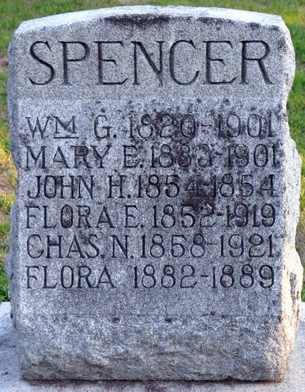
Photo by Deb Curry

William Griffith Spencer, the subject of this sketch, was born in Schuylkill County, Pennsylvania, January 20, 1820, and passed away at his home in Decatur, Indiana, Friday, March 15, 1901, in full possession of all his faculties, at the advanced age of eighty-one years, one month and twenty-five days.
One daughter, Mrs. W. L. Gardner, of Rapid City, South Dakota, two sons, William G., Jr., Charles N., and one grandson, Dent W. Spencer, all of Decatur, Indiana, remain.
From a family of thirteen children of which the subject was the oldest, but two, Elen and Martin are now living. Of his ancestors, his father was of English and mother of Scotch descent. In the fall of 1821, his parents moved to Jersey Shore, Pennsylvania, where they resided until 1837, when the family migrated to the west and settled in New Carlisle, Clark County, Ohio.
In the fall of 1840, he came with his parents to Jay County, Indiana, where his parents lived until moving to Adams County in 1852; during this time he studied law with the late Moses V. Jenkinson, and was admitted to the bar in Fort Wayne, Indiana in the year 1845; and in 1849 commenced the practice of law in Decatur, Indiana.
On the 8th of May, 1851, he was united in marriage with Mary E. Nevins, only daughter of Rev. John H. Nevins, then pastor of the First Presbyterian Church of Decatur, Indiana. In 1852, he was elected a Representative of the General Assembly of Indiana from Adams County, serving the state one term. In 1857, he associated himself with Henry L. Phillips in the newspaper business and established the Decatur Eagle, (since changed to the Democrat), which has continuously been the official organ of the democratic party of the county to the present time. In 1859 he was elected to the office of County Auditor, and re-elected in 1863, serving in that capacity for eight years.
On receiving the nomination for County Auditor, he disposed of his interest in the Decatur Eagle, but always kept in touch with the political world. In politics he was an unswerving democrat of the old Jacksonian school, and for many years was a useful and active member of his party, serving for several years as a member of the county central committee. In 1866 he engaged in the hardware business in the south room, now occupied by Brittson Bros., at which place he continued in business until he retired to private life on account of ill health in 1887, since which time he has been too frail to engage in any active business.
About the year 1875, he became a member of the board of education and served until about 1890; during his term of office the graded school system was established in the Decatur schools, and he took an active interest in the building of the central and second ward buildings.
He joined Fort Wayne Lodge, I. O. O. F. No. 14, in May, 1854 and became a charter member of St. Mary's Lodge. No. 167, I. O. O. F., in the year 1855, serving his lodge as trustee for more than thirty years, and was devoted to its principals. He passed the chairs and was admitted a member of the Grand Lodge of Indiana. He became a charter member of Decatur Encampment, I. O. O. F., No. 138 at its organization on October 15, 1875.
In early life he became a member of the Methodist Episcopal Church, but for many years he has held to the faith of the Presbyterian church and served them as trustee for many years, and late in life became a member of the First Presbyterian Church of Decatur, Indiana.
His life was one of great activity, a man of integrity, good executive ability, great energy, and devoted to principal.

Decatur Democrat, Adams County, Indiana
Thursday, March 21, 1901
**
Indiana, U.S., Death Certificates, 1899-2017

Name William G Spencer
Gender Male; Race White; Marital Status Widower
Age 81; Birth Date abt 1820
Birth Place Schuylkill Co Pennsylvania
Death Date 15 Mar 1901
Death Place Decatur, Adams, Indiana, USA
Father James Spencer
Mother Sarah King Macdonald
Informant C N Spencer
Burial Maplewood Cemetery 3/17/1901

