Sarah King (McDonald) Spencer
October 12, 1801 – July 10, 1856

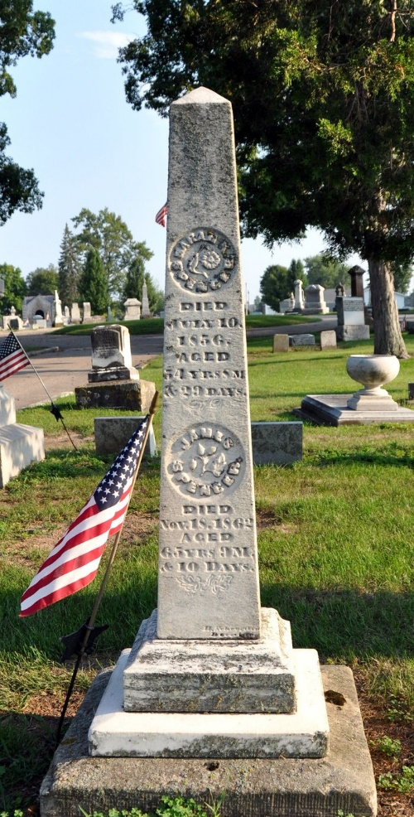
Photo by Deb Curry

Sarah King McDonald from tree Klosterman Family Tree
Birth 12 Oct 1801 Pennsylvania, USA
Marriage 26 Apr 1818 Philadelphia, Philadelphia, Pennsylvania, USA
Residence 1850 Jay, Indiana, USA
Death 10 Jul 1856 Adams, Indiana, USA
Father James McDonald (1747-1813)
Mother Sarah
Spouse James Spencer (1797-1862)

