Mary Elizabeth (Nevins) Spencer
March 1, 1833 – January 9, 1901

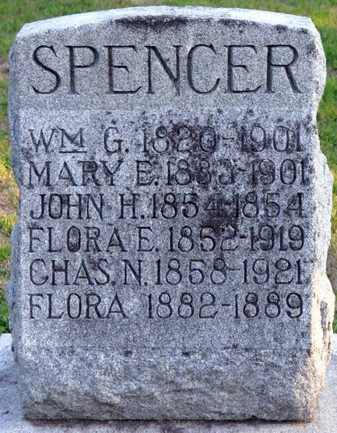
Photo by Deb Curry

Mary E. Nevins, wife of W. G. Spencer, died at her home on Second Street, Wednesday night, January 9, at 11 o'clock. She was born in Oxford, Ohio, March 1st, 1833. She came with her parents to Decatur in the fall of 1842, and was married to W. G. Spencer, May 8th, 1851.
Her aged husband and three children, Mrs. Flora Gardner of Rapid City, South Dakota, W. G. Jr. and Charles N. Spencer of Decatur, survive her.
She was the daughter of the Rev. J. Nevins, first pastor of the First Presbyterian Church of Decatur, of which church she was a member for more than 50 years.
The funeral services were held at her home Sunday afternoon, January 13th, and were conducted by the Rev. H. C. Duckett, pastor of the First Presbyterian Church.
W. G. Spencer and family wish in this way to thank their many friends for kindness to them before as well as during their sad bereavement.

Decatur Democrat, Adams County, Indiana
A weekly newspaper
Thursday, January 17, 1901
**
Indiana, U.S., Death Certificates, 1899-2017
Name Mary Elizabeth Spencer
[Mary Elizabeth Nevens]
Gender Female
Race White
Marital Status Married
Age 67y 10m 8d
Birth Date abt 1834
Birth Place Oxford, Ohio
Death Date 9 Jan 1901
Death Place Decatur, Adams, Indiana, USA
Death Registration Date 1901
Father John Henry Nevens
Mother Catherine Brown
Burial Maplewood Jan 13, 1901

