John Henry Nevius Spencer
October 5, 1854 – October 10, 1854

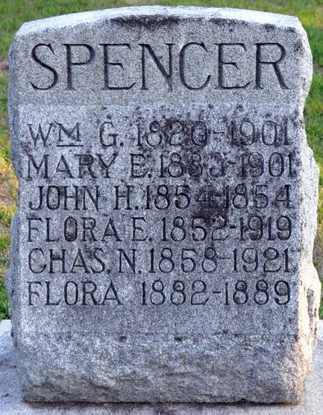
Photo by Deb Curry

John Henry Nevius Spencer from tree Gary Lyle Nevius Family Tree
Birth 5 Oct 1854 Indiana, USA
Death 10 Oct 1854 Indiana, USA
Father William Griffith Spencer (1820-1901)
Mother Mary Evelina Nevius (1833-1901)

