James Shaver Spencer
November 14, 1834 – February 11, 1864

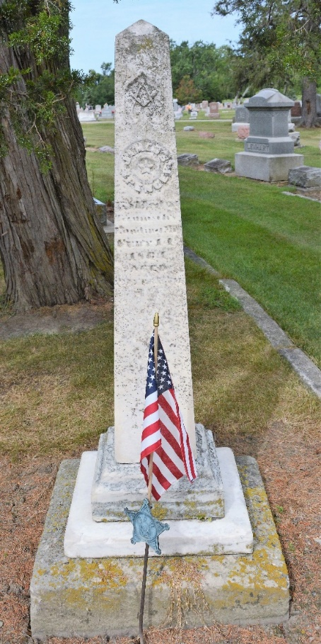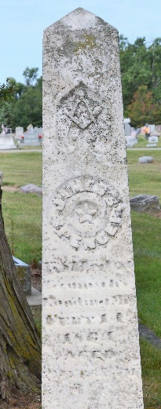
Photo by Deb Curry

Spencer, James, killed at Tecumseh Landing, Miss., February 11, 1864, age 29 yrs. 3 mo. G.A.R.

Adams County (IN) Public Library
Maplewood Cemetery Burials

**
James Shaver Spencer from tree Gerard Spencer of Haddam 2023
Birth 14 Nov 1834 Jersey Shore, Lycoming, Pennsylvania, USA
Residence 1850 Jay, Indiana, USA
Death 11 Feb 1864
Father James Spencer (1797-1862)
Mother Sarah King McDonald (1801-1856)

