James Spencer
February 8, 1797 – November 18, 1862

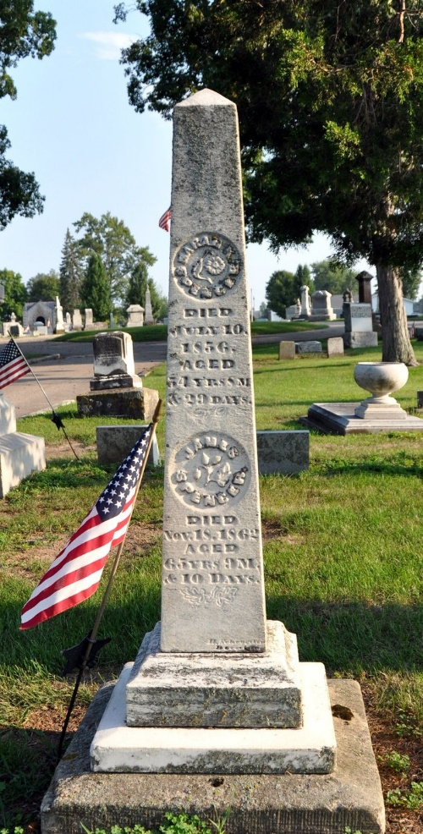
Photo by Deb Curry

James Spencer from tree Gerard Spencer of Haddam 2023
Birth 8 Feb 1797 Philadelphia, Philadelphia, Pennsylvania, USA
Marriage 1859 Decatur, Adams, Indiana, USA
Residence 1860 Adams, Indiana, USA
Death 18 Nov 1862 Adams, Indiana, USA
Father James Spencer (1779-1863)
Mother Charlotte Bartholomew (1777-1863)
Spouse Sarah King McDonald (1801-1856)
Spouse Jane Elizabeth Wise (1825-1876)

