Flora Spencer
1882 - 1889

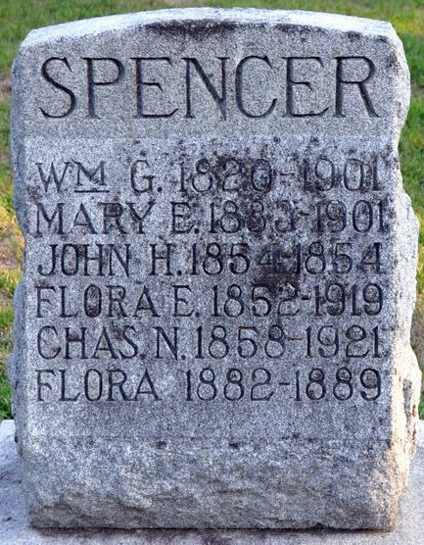
Photo by Deb Curry

Flora Spencer from tree Gary Lyle Nevius Family Tree
Birth 1882 Indiana, USA
Death 1889 Indiana, USA
Father William Griffith Spencer (1820-1901)
Mother Mary Evelina Nevius (1833-1901)

