Charles N. Spencer
August 10, 1858 – August 18, 1921

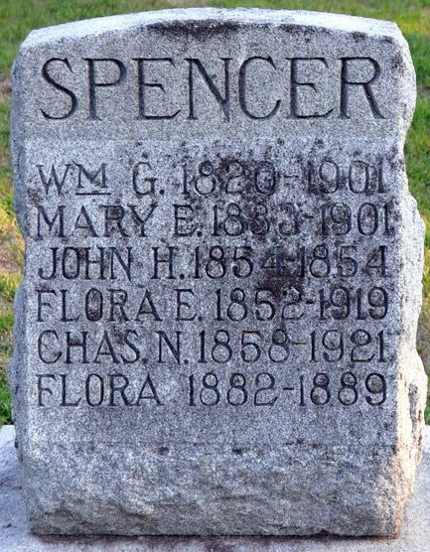
Photo by Deb Curry

Charles Speneer
in the Indiana, U.S., Death Certificates, 1899-2017

Name Charles Spencer
Gender Male
Marital Status Single
Age 63
Birth Date 10 Aug 1858
Birth Place Indiana
Death Date 18 Aug 1921
Death Place Fort Wayne, Allen, Indiana, USA
Death Registration Date 1921
Father William Spencer
Mother Mary Nevius
Informant William Spencer; Decatur, Indiana
Burial August 20, 1921; Decatur, Indiana

