Carrie E. Spencer
June 3, 1861 – November 5, 1870

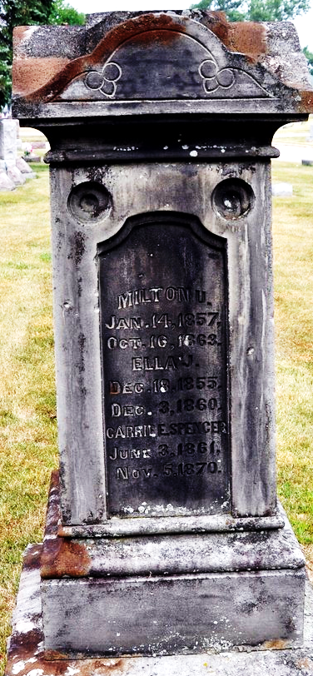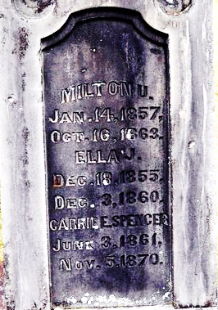
Photo by Deb Curry

Carrie E Spencer from tree Wise Family Tree
Birth 3 Jun 1861 Decatur, Adams, Indiana, USA
Residence 1870 Decatur, Adams, Indiana, USA
Death 5 Nov 1870 Decatur, Adams, Indiana, USA
Father James Spencer (1797-1862)
Mother Jane Elizabeth Wise (1825-1876)

