Robert F. Speakman
February 2, 1935 – August 14, 2009

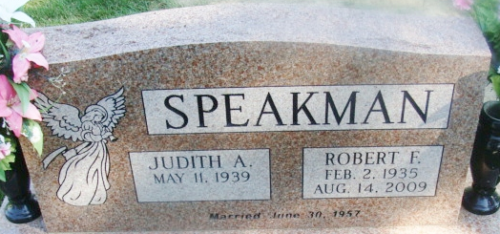
Photo by Alicia Kneuss

Robert F. Speakman, 74, of Columbia City and a former longtime resident of Decatur, died at 5:15 a.m. Friday, Aug. 14, 2009 at Coventry Meadows, Fort Wayne. Born on Feb. 2, 1935 in Decatur, Ind., he was a son of Richard and Rhoda (Jones) Speakman.
On June 30, 1957 he married Judith Ann Gephart in Decatur.
He was a graduate of Pleasant Mills High School class of 1953. He retired in 1979 after 26 years of service from the Adams County Co-op where he was the manager of Williams Elevator. He was also a longtime St. Mary's Township farmer.
He attended the former Crossroads Church in Decatur.
Survivors include his wife, Judith of Columbia City, daughters Cindy (Russell) Strickler of Belgrade, Mont.; Michelle (Micah) Thomas of Columbia City, Allison (Kepoe) Ioane of Columbia City; a son, Jeffrey (Cheryl) Speakman of Romney, Ind.; brothers, Paul Speakman of Breckenridge, Minn. and David Speakman of Syracuse, Ind.; sisters Mary Sutherland of Wilmore, Ky.; Arylene Kelsey of Florence, Ky.; Ellamae Haessig of Syracuse, Ind. and 14 grandchildren.
He was preceded in death by four brothers; Harry, John, Tom and Lee Speakman.
Services will be at 10:00 a.m. Tuesday at Zwick and Jahn Funeral Home, Decatur Ind. with Pastor Scott Jester officiating.
Burial will be at Decatur Cemetery. Visitation is from 2 to 5 and 6 to 8 p.m. Monday at Zwick & Jahn Funeral Home.
Memorials may be given to HCJB Global for missionary Steven Sutherland.

Zwick & Jahn Funeral Home, Adams County, Indiana
August 14, 2009

