Richard Raymond Speakman
December 7, 1903 – October 21, 1972

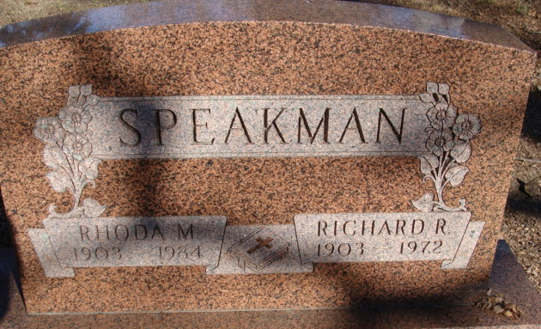
Photo by Alicia Kneuss

Richard Speakman Dies this Morning
Richard R. Speakman, 68, well known retired farmer and electrician, died suddenly at 12:30 a.m. today at his home on Decatur route 6, five miles southeast of Decatur. He had been in failing health for several years but death was unexpected. Mr. Speakman was pastor of the Calvary Community Church from 1968 to 1970, when he retired due to ill health.
Born in Blue Creek Township Dec. 7, 1903, he was a son of William and Ella Smitley-Speakman, and was married to Rhoda Jones April 12, 1924.
Surviving are his wife; seven sons, Rev. Harry Speakman of Irwin, Pa., Rev. H. Lee Speakman of San Diego, Calif., Paul Speakman of Breckenridge, Minn., Tom Speakman of Grover Hill, O., Robert and John Speakman, both of Decatur route 6, and David Speakman of Cromwell; three daughters, Mrs. Robert (Mary) Sutherland of Colombia, South America, Mrs. Ronald (Arylene) Kelsey of Erlanger, Ky., and Mrs. Roger (Ellamae) Haessig of Decatur route 6; one sister, Mrs. Curtis (Mary) Hill of Decatur; one brother, Rollie Speakman of Fort Wayne; and 25 grandchildren. One sister, Mrs. Edna Sheets, and one brother, Roy, are deceased.
Funeral services will be conducted at 1:30 p.m. Tuesday at the Zwick Funeral Home, with Rev. Lawrence T. Norris officiating. Burial will be in Decatur Cemetery. Friends may call at the funeral home after 7 p.m. Sunday until time of the services.

Decatur Daily Democrat, Adams County, Indiana
Saturday, October 21, 1972

