Rhoda M. (Jones) Speakman
December 27, 1903 – January 9, 1984

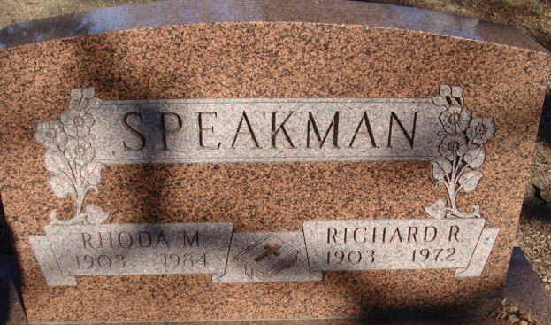
Photo by Alicia Kneuss

Rhoda M. Speakman
in the Indiana, U.S., Death Certificates, 1899-2017

Name Rhoda M. Speakman
[Rhoda M. Jones]
Gender Female
Race White
Marital Status Widowed
Age 80
Birth Date 27 Dec 1903
Birth Place Indiana
Death Date 9 Jan 1984
Death Place Decatur, Adams, Indiana, USA
Death Registration Date 1984
Father Esaias Thomas Jones
Mother Mary Rawley
Informant Robert Speakman; son; Decatur, Indiana
Burial January 12, 1984; Decatur Cemetery; Decatur, Indiana

