Judith Ann (Gephart) Speakman
May 11, 1939 – March 29, 2024

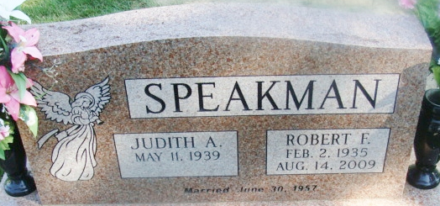
Photo by Alicia Kneuss

Judith A. Speakman, 84, of Warren, Indiana, passed away on Friday, March 29, 2024 at Parkview – Huntington Hospital. She was born on May 11, 1939 in Decatur, Indiana to the late True J. Gephart and the late Irene R. (Kaehr) Gephart. Judy was united in marriage to Robert F. Speakman on June 30, 1957 in Decatur, and he preceded her in death on August 14, 2009.
Judy attended First Baptist Church in Warren, Indiana. She participated in numerous Bible studies.
Judy graduated from Decatur High School in 1957. She worked for General Electric Company for 9 years, Decatur Industries for 7 years and Precision Woodcrafters for 5 years. She then retired from Berne Furniture Company on April 30, 2004 after 6 years of employment.
Judy loved spending time with her family…they brought much joy to her life. Cooking was her love language. She loved to cook and bake, but especially Christmas cookies and candies. She loved to watch her birds and had breakfast with them every day. Beyond her love of family and hobbies, she was most devoted to her faith in Jesus Christ. We rejoiced as a family when she placed her hand into the hand of Jesus, and He walked her into heaven on Good Friday.
Survivors include her daughter, Cindy (Rev. Russell) Strickler of Warren, Indiana; daughter, Michelle (Micah) Thomas of Speedway, Indiana; daughter, Allison (Kepoe) Ioane of Columbia City, Indiana; son, Jeffrey (Cheryl) Speakman of Anderson, Indiana; sister, Nancy (John) Hackworth of Decatur, Indiana; Fourteen Grandchildren, Melinda (Tom) Healy, Kendra (Jason) Stephens, Jana Strickler, Jeremiah Strickler, Sandi (Ryan) Sprunger, Kyle (Tracie) Speakman, Courtney (Sean) FitzSimons, Darci (Brad) Church, Michaela (Evan) Wadsworth, Kiersten (Dan) Yingst, Tori (Zion) Osner, Stuart Ioane, Isaac Ioane, and Gabe Ioane; and Eleven Great-Grandchildren.
In addition to her husband and parents, Judy was preceded in death by her brother, Steven Gephart and her sister, Charlotte Spencer.
A funeral service will be held at 6:00 p.m. on Wednesday, April 10, 2024 at Zwick & Jahn Funeral Home – Decatur with Pastor Russell Strickler officiating. Burial will follow in Decatur Cemetery. Family and friends will be received from 4:00 p.m. until service time on Wednesday also at Zwick & Jahn Funeral Home – Decatur.
Preferred memorials can be given to Steve Sutherland – Missionary, Reach Beyond Ministry.

Zwick & Jahn Funeral Home, Adams County, Indiana
March 31, 2024

