Joyce Ann (Irwin) Speakman
September 16, 1939 – April 17, 2025

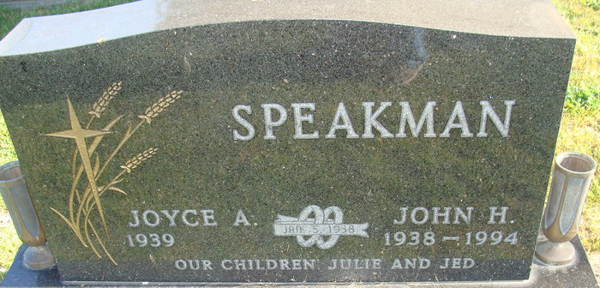
Photo by Alicia Kneuss

Joyce Ann Speakman, 85, of Decatur, Indiana passed away early Thursday morning, April 17, 2025, at Adams Woodcrest. Joyce was born on September 16, 1939 in Adams County, Indiana to Harry O “Jack” and Imogene I. (Clifton) Irwin. On January 5, 1958, Joyce was united in marriage to John H. Speakman and he preceded her in death on October 14, 1994.
She was a lifelong member of the Decatur Church of God. Joyce was a 1957 graduate of Adams Central High School. She retired from Adams Central Community Schools with over 30 years of service as the secretary for the elementary school principal. Following her retirement, she worked as the aftercare coordinator for 17 years, and was responsible for the development of that program, for Zwick & Jahn Funeral Homes.
Joyce had a rare gift of hospitality, not just the way she welcomed people into her home, but the way she welcomed them into her heart. She had a special ability to create safe spaces where others felt seen, heard and valued. Her warmth, gentle spirit, and sincere compassion turned every gathering into something sacred, whether it was a simple dinner or a heartfelt conversation over coffee. She enjoyed traveling with family and close friends, especially the “golden girls”.
God and family were the cornerstone of Joyce’s life. She cherished every moment spent with her loved ones and held them close in her heart. She was a source of strength, laughter, and unconditional love, always showing up with open arms and a listening ear. Her professional life reflected the same care and dedication. She didn’t just work…she served. Every job she held was made meaningful by the relationships she formed. She found purpose in the people she worked alongside and was known for her unwavering encouragement and genuine love for others.
She is survived by her daughter, Julie (Dennis) Call of Decatur, Indiana; son, Jed Speakman of Decatur, Indiana; sister, Judy (Kevin) Fuhrman of Decatur, Indiana; brother, Ned (Ann) Irwin of Buckeye, Arizona; grandson, Jonathan (Hillary) Call; granddaughter, Kayli (Doug) Roop; and great-grandchildren, Jackson Call, Marlowe Joy Roop, Olive Anne Roop, Brooks Call, and Owen Fogarty. In addition to her parents and husband, she was preceded in death by her granddaughter-in-law, Ashley (Osterman) Call.
A funeral service will be held at 10:30 a.m. on Wednesday, April 23, 2025, at Decatur Church of God with Pastor Brent Doster officiating. Burial will follow at Decatur Cemetery. The family will receive friends at the Woodcrest Chapel from 2 to 3 p.m. on Tuesday, April 22, 2025, then at Zwick & Jahn Funeral Home, Decatur from 5 to 8 p.m. on Tuesday, April 22, 2025, and from 9:15 to 10:15 a.m. on Wednesday, April 23, 2025 at Decatur Church of God.
Preferred memorials are to Decatur Church of God.

Zwick & Jahn Funeral Home, Adams County, Indiana
April 18, 2025

