John H. Speakman
July 13, 1938 – October 14, 1994

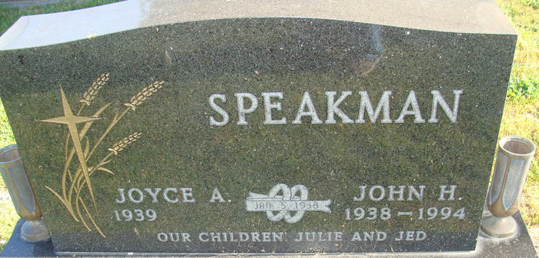
Photo by Alicia Kneuss

John H. Speakman, of Decatur died yesterday at home. He retired from the Adams County Co-Op Williams Elevator after 31 years of service.
Surviving are his wife, Joyce A. of Decatur; a son, Jed Deon of Atlanta; sisters, Ellamae Haessig of rural Decatur, Mary Sutherland of Ecuador, South America, and Arlyene Kelsey of Athens, Ga.; brothers, Robert Speakman of rural Decatur, Thomas Speakman of Grover Hill, Ohio, H. Lee Speakman of Billings, Mont., Paul Speakman of Breckenridge, Minn., and David Speakman of Syracuse; and a grandson.
Services are 2 p.m. Tuesday at the Decatur Church of God, where calling will be from 1 to 2 p.m. Tuesday. Calling will also be 2 to 9 p.m. tomorrow and 2 to 9 p.m. Monday in Zwick Sefton & Jahn Funeral Home in Decatur. Burial will be in Decatur Cemetery.
Preferred memorials are gifts to Decatur Church of God.

News-Sentinel, Allen County, Indiana
Saturday, October 15, 1994
**
Indiana, U.S., Death Certificates, 1899-2017
Name John H Speakman
Gender Male
Race White
Marital Status Married
Age 56
Birth Date 13 Jul 1938
Birth Place Decatur, Indiana
Death Date 14 Oct 1994
Death Place Decatur, Adams, Indiana, USA
Death Registration Date 1994
Father Richard R Speakman
Mother Rhoda M Jones
Spouse Joyce A Irwin Speakman, informant
Burial Oct 18, 1994 Decatur Cemetery

