Sylvester Spangler
February 19, 1842 – October 27, 1921

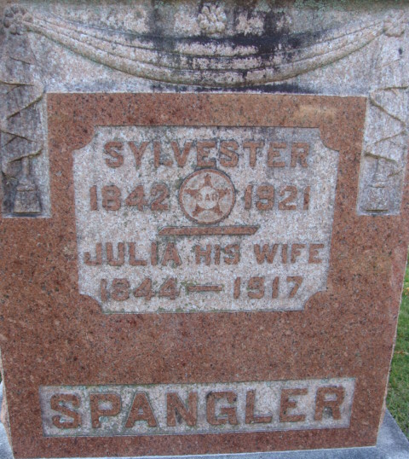
Photo by Alicia Kneuss

LAST CALL COMES TO MR. SPANGLER
Veteran of Civil War Died at 9 O'clock This Morning at Daughter's Home - HAD BEEN ILL LONG - Was a Resident of Adams County Many Years - Funeral Saturday Afternoon

After months of suffering from hardening of the arteries and infirmities due to his advanced age, Sylvester Spangler, one of the best known men in the city and county, died at the home of his daughter, Mrs. R. J. Rice, at 9 o'clock this morning, having reached the advanced age of seventy-nine years, eight months and eight days.
Mr. Spangler was born in Crawford County, Ohio, February 19, 1842, a son of Michael and Dorothy Kiess Spangler. The family came to Adams County when he was but four years old, and resided here continuously since. He was married January 25, 1866 to Miss Julia Gillig. Two daughters were born to the union, Mrs. C. E. Neptune, who died in 1916, and Mrs. B. J. Rice, at whose home the father passed away today. The wife died December 6, 1917.
Besides the one daughter, there is one grandson, Kenneth Neptune, who left only last Saturday for Alameda, Col., where he will take up the profession of a chiropractor, having purchased the business some time ago; two great-grandchildren, Theresa Adell and Herman Robert Neptune; two sisters, Mrs. J. R. Schafer, Dallas, Texas, and Mrs. Susan Reppert, of Nebraska; one brother, George Spangler, Los Angeles, Cal.
Mr. Spangler was a member of the Grand Army of the Republic, having served in the Civil War as a member of the 51st Indiana Volunteer Regiment. He served in several of the battles and skirmishes during his service. During the last several years he had lived a retired life, but in early years was a carpenter and contractor here.
Funeral services will be Saturday afternoon at 2:30 o'clock from the Methodist church, the Rev. Tinkham officiating. Burial will be at the Decatur Cemetery.

Decatur Daily Democrat; Adams County, Indiana
Thursday, October 27, 1921

**
SYLVESTER SPANGLER, contractor and builder, and an active and enterprising citizen of Decatur, is a native of Crawford County, Ohio, born near Massillon, February 19, 1842, a son of Michael and Dorothy (Keese) Spangler. When an infant, in 1843, his parents came to Adams County, Indiana, and here he was reared to the avocation of a farmer on his father's farm. On reaching manhood he learned the carpenter's trade at Fort Wayne.
In the fall of 1863, he enlisted in the Union Army as a private in Company I, Fifty-first Indiana Infantry, to serve one year. He served his country for thirteen months, when he was discharged at New Orleans. He participated in tile engagements at Franklin and Nashville beside several skirmishes, and during his term of service was not off duty a day on account of sickness or wounds. After his discharge he returned to Adams County and worked at carpentering at Decatur and vicinity.
He was married at Decatur in 1865, to Julia Gillig, daughter of Francis J. and Theresa (Spuler) Gillig. She was born, reared and educated at Decatur, and before her marriage taught school in Adams County. Mr. and Mrs. Spangler are the parents of two children - Ella and Della, both of whom are students at the Decatur High School.
In 1868 Mr. Spangler engaged in contracting and building, which he has since followed, and has erected many of the brick business blocks on Main Street, beside many of the substantial residences at Decatur. In politics Mr. Spangler is a Democrat. He served four years as village trustee of Decatur, and since its organization as a city he has been councilman five years. He is a comrade of Sam Henry Post, No.63, G. A. R. He and his family are members of the Methodist Episcopal church at Decatur.
Michael Spangler, the father of our subject, was a native of Ohio, born January 12, 1812, and was of German descent. He was a farmer by avocation, and on coming to Adams County he settled on a tract of wild land in Preble Township, which he improved and lived on for about twenty-four years. He then sold his land in Preble Township and removed to a farm in Allen County near Williamsport, where he died September 8, 1877.
The mother of our subject was born in Stuttgart, Germany, February 16, 1811. When she was twelve years of age she was brought by her parents to America, they located in Liverpool, Ohio, where she lived till her marriage. She died on the farm near Williamsport, Allen County, October 3, 1869. She was a member of the Evangelical Church. Mr. Spangler was a member of the United Brethren Church. Eight of the ten children born to them grew to maturity, of whom seven are yet living, one living in Nebraska, and the remaining six being residents of Indiana.

Biographical and Historical Record - Adams and Wells Co. Indiana Lewis Publishing Co. Chicago, IL 1887

