Samuel J. Spangler
September 21, 1862 – April 28, 1928

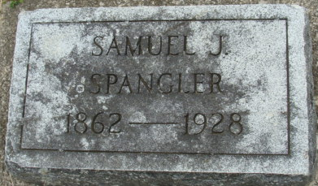
Photo by Alicia Kneuss

S. J. Spangler Dies Suddenly - Prominent Retired Farmer of Root Township Dies of Cerebral Hemorrhage
S. J. Spangler, 65, prominent retired farmer of Root township, died suddenly at 4:30 o'clock this morning, April 28, 1928, death being due to a cerebral hemorrhage. The Spangler family resides near the Mt. Pleasant Church.
S. J. Spangler, son of Jacob and Margaret Spangler, was born September 21, 1862 in Adams County. He resided in the same community throughout his entire life. In the year 1894, he united in marriage with Louise Armack, who survives him.
Two daughters, Mrs. Bertha A. Thompson, of Lagro, Indiana, and Miss Iva M. Spangler at home, also survive. Mrs. Mary Henschen of Kirkland Township and Miss Eliza Spangler of this city, are sisters of the deceased. Three brothers are: the Rev. Dan Spangler, of New Carlisle, Indiana; the Rev. Chas. W. Spangler, of Peru, and J. E. Spangler, of Root Township.
Funeral services will be held Monday afternoon, at 2 o'clock at the home and at 2:30 o'clock at the Mt. Pleasant Church.

Decatur Daily Democrat, Adams County, Indiana
Saturday, April 28, 1928
**

Indiana, U.S., Death Certificates, 1899-2017
Name Samuel J. Spangler
Gender Male
Race White
Marital Status Married
Age 65
Birth Date 21 Sep 1862
Birth Place Indiana
Death Date 28 Apr 1928
Death Place Root, Adams, Indiana, USA
Death Registration Date 1928
Father Jacob Spangler
Mother Margaret Baker
Spouse Louise E.
Informant Louise E. Spangler; Decatur, Indiana
Burial April 30, 1928; Reynolds Cemetery**

**
From Nola Rains - I stopped at the office next door (the former Liby Monuments). Clay Smith is the owner now. His wife checked the records and it shows that Samuel J. Spangler died 30 April 1928, was originally buried at Reynolds, and was reinterred on 24 April 1943 at Decatur Cemetery.

