Louise Elizabeth (Armack) Spangler
August 6, 1867 – March 23, 1943

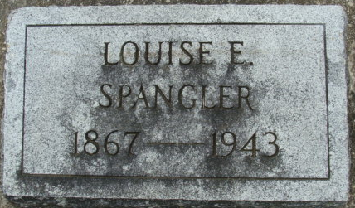
Photo by Alicia Kneuss

Mrs. Louise Elizabeth Spangler, 75 died at 4:15 o'clock Tuesday afternoon at her home at 128 East Foster Parkway, following an extended illness. She was a member of Wayne Street Methodist Church and the W.S.C.S.
Survivors include two daughters, Mrs. Bertha Thompson of Albion and Miss Iva Spangler, a Central High School teacher, at home; two grandchildren, Mrs. Elizabeth Poor of Albion and Robert Thompson in the merchant Marine; two great-grandchildren, Richard Poor of Albion and Robert L. Thompson of South Bend; a brother Henry Armack, and three sisters, Mrs. Amelia Karns, Mrs. Ida Penny and Mrs. Emma Smith, all of Mound City, MO.
The body was removed to Klaehn & Sons' Funeral Home where it may be viewed after 6 o'clock tonight. Funeral services will be held at 10:00 Friday morning from the funeral home, Rev. B. Brooks Shake officiating. Burial is to follow in Maplewood Cemetery at Decatur. The body may be viewed after 6 o'clock tonight.

Journal Gazette, Allen County, Indiana
Wednesday, March 24, 1943

**
Indiana, U.S., Death Certificates, 1899-2017
Name Louise Elizabeth Spangler [Louise Elizabeth Armack]
Gender Female
Race White
Marital Status Widowed
Age 75
Birth Date 6 Aug 1867
Birth Place Adams County, Indiana
Death Date 23 Mar 1943
Death Place Fort Wayne, Allen, Indiana, USA
Father August Armack
Mother Agnes Hoelle
Spouse Samuel J Spangler
Informant Miss Iva Spangler
Burial March 26, 1943; Maplewood Cemetery; Decatur, Indiana

