Iva M. Spangler
February 14, 1898 – May 18, 1986

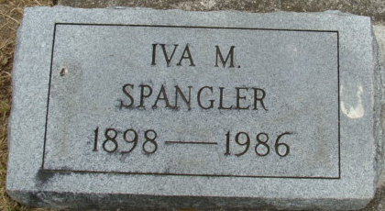
Photo by Alicia Kneuss

Iva M Spangler
in the Indiana, U.S., Death Certificates, 1899-2017
Name Iva M Spangler
Gender Female
Race Caucasian (White)
Marital Status Never Married (Single)
Age 88
Birth Date 14 Feb 1898
Birth Place Indiana
Death Date 18 May 1986
Death Place Fort Wayne, Allen, Indiana, USA
Death Registration Date 1986
Father Samuel J Spangler
Mother Louise E Armack
Informant Richard Poor; nephew; Fort Wayne, Indiana
Burial May 21, 1986; Decatur Cemetery; Decatur, Indiana

