Eliza C. Spangler
August 30, 1860 – December 13, 1951

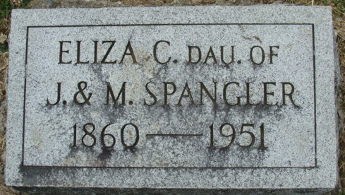
Photo by Alicia Kneuss

Eliza C. Spangler Dies This Morning
91-Year-Old Lady Is Taken By Death
Miss Eliza C. Spangler, 91, lifelong resident of Adams County, died at 7 o'clock this morning at her home, 813 West Madison Street, following an illness of three weeks of infirmities.
She was born in Root Township Aug. 30, 1860, a daughter of Jacob and Margaret Baker-Spangler, and had never married. She had lived in Decatur for the past 50 years.
Miss Spangler was a member of the Bethany Evangelical United Brethren Church.
She was the last surviving member of her family, five brothers and one sister preceding her in death. Survivors include two nieces, Miss Iva Spangler of Fort Wayne and Mrs. Ida Yaney of Kirkland Township, who assisted in caring for her.
Funeral services will be conducted at 1:30 p.m. Saturday at the Black Funeral Home, the Rev. F. H. Willard officiating. Burial will be in the Decatur Cemetery. Friends may call at the funeral home after 10 o'clock Friday morning.

Decatur Daily Democrat, Adams County, Indiana
Thursday, December 13, 1951

